VISUAL DESIGN report

CarDiag Mobile Application

Group 12

1. Introduction
After completing the requirements analysis and system design phases, the next step in the software development process is the creation of the visual design. This phase focuses on transforming system functionalities into an interactive and user friendly mobile interface.
CarDiag is a mobile application developed to assist vehicle owners in identifying vehicle faults, understanding dashboard warning indicators, recording engine sounds, viewing diagnosis results, and accessing repair tutorials. The visual design aims to provide a simple, professional, and efficient user experience while maintaining consistency across all screens.

2. Design Objectives
The visual design of CarDiag was developed according to the following objectives:
- Create a modern and professional automotive interface.
- Provide clear navigation between application features.
- Minimize user effort when performing vehicle diagnosis.
- Ensure readability of diagnostic information.
- Maintain consistency throughout the application.
- Support both Android and iOS devices.

3. Design Principles
The interface was designed based on the following principles:

Simplicity
Users should be able to access important features without navigating through multiple screens.

Consistency
Buttons, cards, icons, and navigation elements maintain the same appearance throughout the application.

Accessibility
Text sizes, spacing, and contrast ratios were selected to ensure readability.

Feedback
The application provides visual feedback for user actions such as scanning, recording, and diagnosis completion.

4. Visual Identity

4.1 Application Name
CarDiag :The application name combines the words “Car” and “Diagnostic” to clearly communicate its purpose.

4.2 Logo Description
The CarDiag logo combines three main elements:
- Vehicle silhouette
- Diagnostic gauge
- Warning indicator
These elements represent vehicle monitoring, fault detection, and maintenance support.

4.3 Application Icon
The application icon consists of:
- Black background
- Electric blue diagnostic gauge
- Orange warning indicator
The icon was designed to remain recognizable on different mobile devices and screen resolutions.

5. Color Palette
The color palette was selected to reflect professionalism, technology, and automotive diagnostics.
Color Role | Hex Code
Primary Color | #1E88E5
Secondary Color | #121212
Accent Color | #FF6D00
Background Color | #F5F5F5
Text Color | #212121
Error Color | #D32F2F
Success Color | #4CAF50

Justification
Electric blue represents technology and reliability.
Black provides a modern and professional appearance.
Orange is used to highlight vehicle alerts and warning indicators.
Red is used for critical vehicle faults.
Green indicates successful operations and completed diagnoses.

6. Typography
To ensure readability and consistency, the following typography system was selected.
Usage | Font
Main Titles | Inter Bold
Section Titles | Inter SemiBold
Body Text | Inter Regular
Diagnostic Codes | Roboto Mono

7. Navigation Design
CarDiag follows a bottom navigation structure.
The navigation bar contains five primary modules:
- Home
- Scan
- Tutorials
- History
- Profile
This structure allows users to access major functionalities from any screen.

8. User Interface Components

Buttons
Primary buttons use electric blue backgrounds with white text.
Secondary buttons use white backgrounds with blue borders.

Cards
Cards are used to display:
- Vehicle information
- Diagnosis results
- Repair tutorials
- Diagnostic history

Input Fields
Input fields contain:
- Rounded corners
- Clear labels
- Validation messages

Status Indicators
Vehicle status indicators use color coding:
- Green for normal conditions
- Orange for warnings
- Red for critical faults
Each screen follows the same visual style to provide consistency and improve usability.we have here the low level quality mockup, to have a visual aspect of our frontend.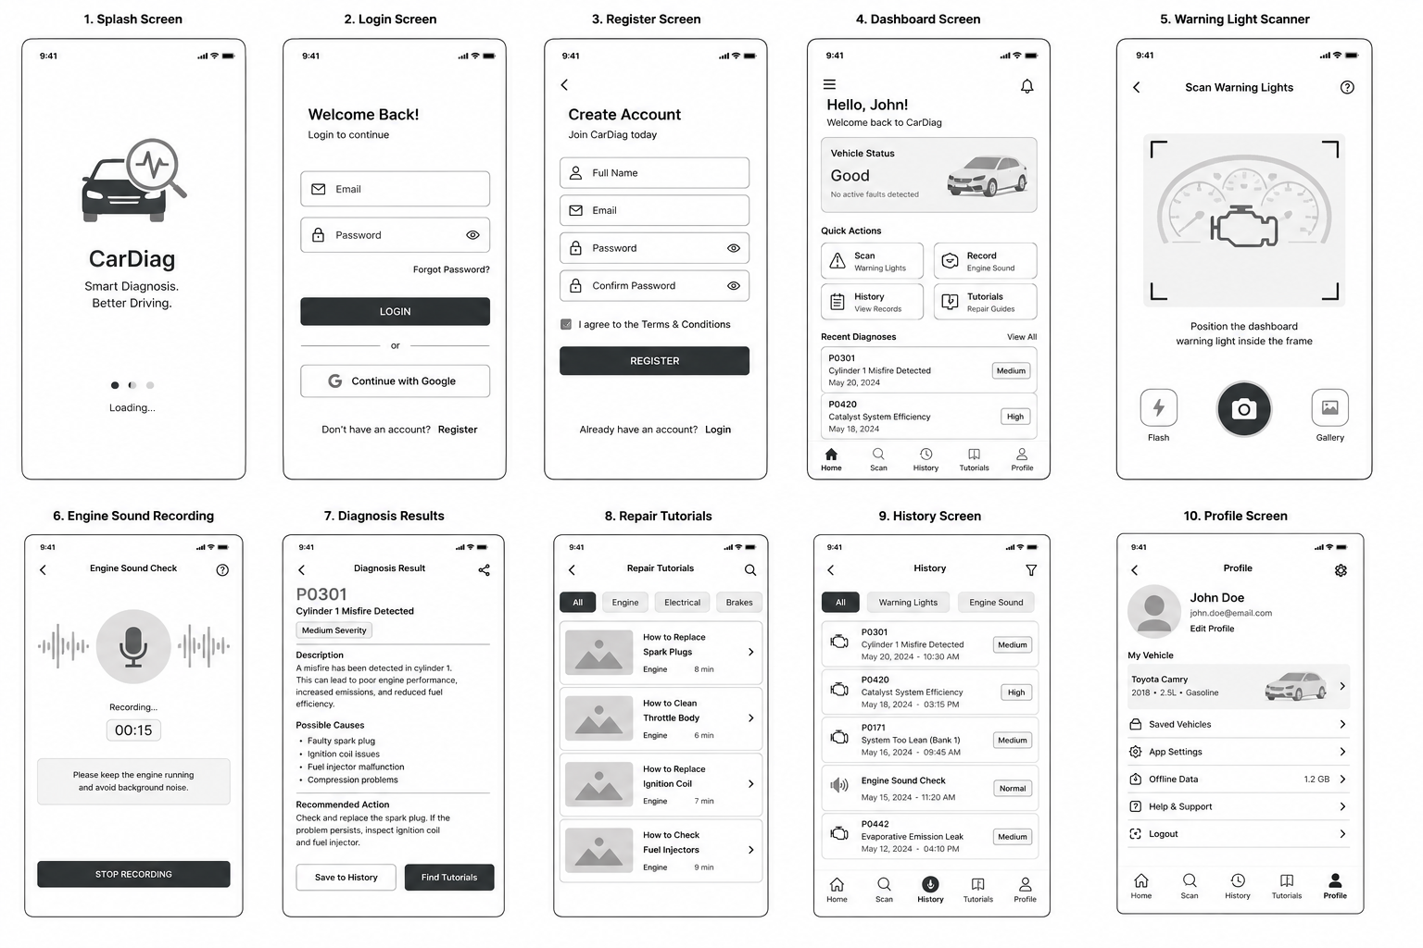
Conclusion
The visual design and frontend specification of CarDiag provide a consistent and professional user experience. Through the use of a carefully selected color palette, structured navigation system, reusable interface components, and intuitive screen layouts, the application enables users to efficiently diagnose vehicle faults and access repair information. The design supports both Android and iOS platforms while maintaining usability, readability, and visual consistency.

